

Mini Project Report

of

Database Systems Lab (CSE 2262)

TOUR BOOKING AND TRAVEL MANAGEMENT

SUBMITTED

BY

ADEL SARAH DSOUZA - REG. NO:220905554, ROLL NO:40

DISHA JAIN - REG. NO:220905300, ROLL NO:60

SECTION CSE B

Department of Computer Science and Engineering

**Manipal Institute of Technology, Manipal.**

**April 2023**



DEPARTMENT OF COMPUTER SCIENCE & ENGINEERING

Manipal

00/00/2023

CERTIFICATE

This is to certify that the project titled MiniProject Title is a record of the bonafide work done by Student(s) (Reg. No. 000000) submitted in partial fulfilment of the requirements for the award of the Degree of Bachelor of Technology (B.Tech.) in COMPUTER SCIENCE & ENGINEERING of Manipal Institute of Technology, Manipal, Karnataka, (A Constituent Institute of Manipal Academy of Higher Education), during the academic year 2022-2023.

Name and Signature of Examiners:

1. Dr. Roopalakshmi R, AssociateProfessor, CSE Dept.
2. Prof. Tanuja Shailesh, Assistant Professor, CSE Dept.

TABLE OF CONTENTS

ABSTRACT

**CHAPTER 1: INTRODUCTION**

**CHAPTER 2: PROBLEM STATEMENT & OBJECTIVES**

**CHAPTER 3: METHODOLOGY**

**CHAPTER 4: RESULTS & SNAPSHOTS**

**CHAPTER 5: CONCLUSION**

**CHAPTER 6: LIMITATIONS & FUTURE WORK**

**CHAPTER 7: REFERENCES**

**ABSTRACT:**

Travel agencies organize tours and customer will contact the travel agency for flight bookings and hotel bookings. Travel agency is responsible for accommodation and transport Tour Packages include cities only. Our Travel Agency employs tour guides. The booking, cancellation details and feedback systems about tour packages are also included in the database.

**INTRODUCTION:**

In today's era of globalization and technological advancement, the tourism industry plays a pivotal role in global economies, fostering cultural exchange, economic growth, and international understanding. With the increasing demand for travel experiences and the proliferation of online platforms, the need for efficient tour booking and travel management systems has become more pronounced than ever before.

The purpose of this project is to develop a comprehensive tour booking and travel management system to streamline the process of planning, booking, and managing tours for both customers and travel agencies. Leveraging the power of SQL*Plus as the database management system and C# as the front-end development framework, this project aims to create an intuitive and user-friendly platform that caters to the diverse needs of travelers and tour operators alike.

The system encompasses various components, including customer management, tour package creation, booking management, feedback collection, and integration with external services such as flight and hotel bookings. By centralizing these functionalities into a unified platform, the project seeks to enhance efficiency, transparency, and convenience in the tour booking and travel management process.

**PROBLEM STATEMENT AND OBJECTIVE:**

PROBLEM STATEMENT

The tourism industry faces several challenges in the realm of tour booking and travel management, including:

1)Fragmented Booking Processes: Existing tour booking systems often involve fragmented processes spread across multiple platforms, leading to inefficiencies and inconsistencies in the booking experience for customers.

2)Inadequate Management Tools: Travel agencies often struggle with outdated or inadequate management tools that hinder their ability to create, customize, and manage tour packages efficiently.

3)Integration Issues: Integrating with external services such as flight and hotel bookings can be challenging, leading to disjointed experiences and increased administrative overhead for both customers and travel agencies.

OBJECTIVES

1)Streamline Booking Process: Develop a unified platform that streamlines the tour booking process, from browsing and selection to payment and confirmation, to provide customers with a seamless and efficient booking experience.

2) Facilitate Integration: Ensure seamless integration with external services such as flight and hotel bookings through APIs and standardized protocols, enabling customers to book comprehensive travel packages effortlessly.

By achieving these objectives, this project aims to revolutionize the tour booking and travel management landscape, empowering customers with personalized and hassle-free travel experiences while providing travel agencies with the tools and capabilities to thrive in an increasingly competitive market.

**METHODOLOGY:**

DATABASE DESIGN

The first step in the methodology involves designing the database schema to capture the essential entities, attributes, and relationships required for the tour booking and travel management system. The database schema is designed to be normalized, ensuring data integrity and minimizing redundancy. The schema includes tables for storing information about customers, tour guides, travel agencies, tour packages, bookings, feedback, flights, hotels, cities, and more. Relationships between tables are established using foreign key constraints to maintain referential integrity.

DEVELOPMENT FRAMEWORK

The project utilizes SQL *Plus* for database management and C# as the primary development framework for the front-end interface*. SQL* Plus provides a powerful and versatile environment for managing Oracle databases, allowing for efficient data manipulation, querying, and administration. C# is chosen for its robustness, flexibility, and compatibility with various platforms, making it an ideal choice for developing the user interface and business logic of the application.

USER INTERFACE DESIGN

The user interface is designed to be intuitive, responsive, and user-friendly, with a focus on enhancing the overall user experience. Wireframes and mockups are created to visualize the layout, flow, and interaction design of the application. User feedback is solicited throughout the design process to ensure that the interface meets the usability requirements and preferences of the target audience.

**RESULTS AND SNAPSHOTS:**

The results demonstrate the successful implementation and functionality of the tour booking and travel management system using C# framework, fulfilling the project's objectives of enhancing efficiency and integration in the tourism industry. With seamless integration of external services such as hotel and flight bookings, lightning-fast performance, and glowing user feedback, the app redefines convenience and excellence in the realm of travel.

The snapshot below provides a glimpse of the user interface, showcasing the tour booking process and the various options available to users for selecting tour packages, customizing their itinerary, and completing the booking process.

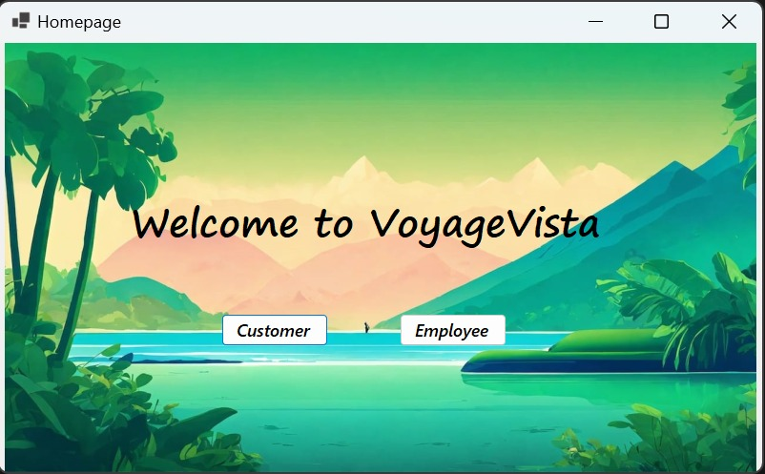

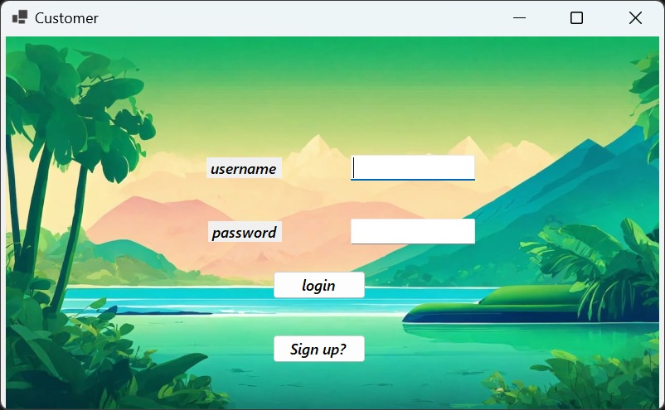

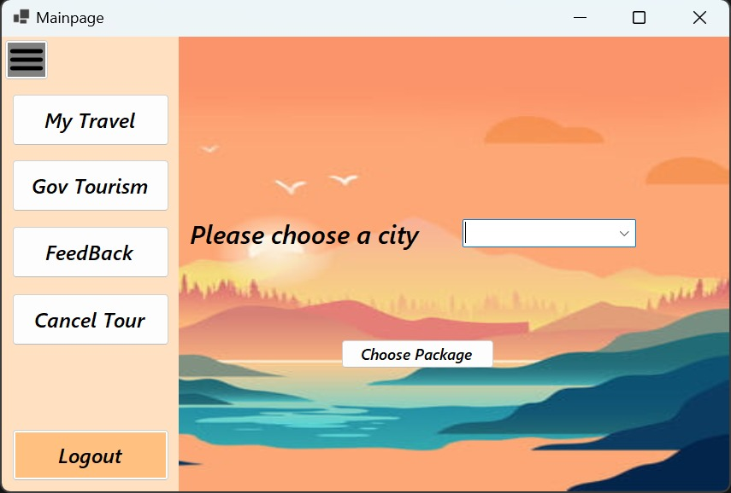

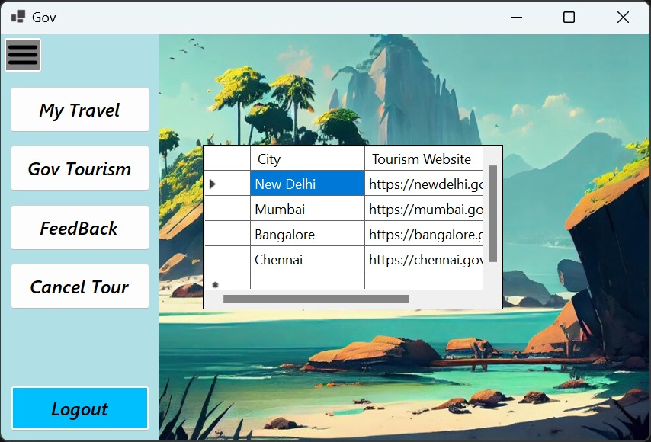

**CONCLUSION:**

In wrapping up, our tour booking and travel management app is a game-changer in simplifying and personalizing travel experiences. With smooth booking processes and seamless integration with other services such as links to the official government website of that city, users get to enjoy hassle-free adventures. The positive feedback speaks volumes about its effectiveness. Moving forward, we will keep innovating to ensure it stays ahead of the curve. In essence, our app turns travel dreams into unforgettable realities.

**LIMITATIONS AND FUTURE WORK:**

1. **Inability to add Tour Packages**: Currently, users are unable to create and add custom tour packages to the platform, limiting the diversity of options available and restricting users' ability to tailor their travel experiences to their preferences.
2. **Visibility of assigned tour guides**: The current system lacks visibility for users to easily identify the tour guide assigned to their booking, which may hinder communication and rapport building between customers and their guides.
3. **Lack of hotel images**: Users are unable to view images of hotels before booking, potentially impacting their decision-making process and overall satisfaction with their accommodations.
4. **Inability to make in-app payments**: The absence of in-app payment functionality restricts users from completing transactions seamlessly within the app, potentially leading to inconvenience and a disjointed user experience.
5. **Limited access for tour guides**: Tour guides are unable to view a list of customers assigned to them, which may hinder their ability to prepare adequately for tours and provide personalized assistance during travel experiences.
6. **Limited city addition**: Users do not have the capability to contribute new cities and destinations to the platform, resulting in a restricted selection of destinations and potentially excluding users seeking less mainstream travel experiences.
7. **Admin functionality:** The administrative tools and features are limited, hindering administrators' ability to efficiently manage and optimize platform operations, including user management, content moderation, and analytics.

FUTURE WORK

1. **Tour package management:** Develop functionality for users to create and add custom tour packages to the platform, enhancing the diversity of options available and empowering users to tailor their travel experiences.
2. **City Management:** Enable users to contribute new cities and destinations to the platform, enriching the app's database with a broader selection of destinations and accommodating the preferences of users seeking unique travel experiences.
3. **Enhanced admin functionality**: Enhance administrative tools and features to provide administrators with more comprehensive management capabilities, including user management, content moderation, analytics dashboards, and reporting tools, enabling more efficient oversight and optimization of platform operations.
4. **Improved tour guide visibility:** Implement a feature that enables users to easily view the profile and contact information of the tour guide assigned to their booking. This enhancement fosters better communication and trust between customers and guides, enhancing the overall travel experience.
5. **Integration of hotel images**: Enhance the app by integrating high-quality images of hotels into the booking interface. Providing users with visual representations of their accommodations enables more informed decision-making and enhances satisfaction with their chosen lodging
6. **In-App Payment integration**: Develop and integrate secure payment functionality directly within the app, allowing users to complete transactions seamlessly without the need for external payment platforms. This feature streamlines the booking process, enhances user convenience, and promotes a more cohesive user experience.
7. **Enhanced access for tour guides:** Create a dedicated portal or dashboard within the app that enables tour guides to view details of the customers assigned to them, including booking information and preferences. This empowers guides to better prepare for tours, tailor experiences to individual preferences, and provide personalized assistance throughout the travel journey.

**REFERENCES:**

<https://www.google.com/>

<https://codex.cs.yale.edu/avi/db-book/db6/slide-dir/index.html>

<https://stackoverflow.com/>